

MATHEMATICS SPECIALIST
MAS3C_D
Section Two
(calculator-assumed)

Student Number: In figures

In words

SEMESTER 1 EXAMINATION 2011
Question/Answer Booklet

Please place your student identification label in this box

Time allowed for this paper
Section One
Reading time before commencing work: Ten minutes
Working time for paper: 80 minutes

Materials required/recommended for this paper
To be provided by the supervisor
Question/answer booklet for Section One and a formula sheet which may also be used for Section Two.

To be provided by the candidate
Standard items: pens, pencils, pencil sharpener, highlighter, eraser or correction fluid, ruler
Special items: drawing instruments, templates, notes on two unfolded sheets of A4 paper, and up to three calculators, CAS, graphic or scientific, which satisfy the conditions set by the Curriculum Council for this course.

Important note to candidates
No other items may be taken into the examination room. It is your responsibility to ensure that you do not have any unauthorised notes or other items of a non-personal nature in the examination room. If you have any unauthorised material with you hand it to the supervisor before reading further.

Structure of this paper

Section | Number of questions available | Number of questions to be answered | Working time (minutes) | Marks available
Section One:  Calculator-free | 6 | 6 | 40 | 35
Section Two:  Calculator-assumed | 11 | 11 | 80 | 65
 |  |  | Total | 100

Instructions to candidates

1. Write your answers in the spaces provided in this Question/Answer Booklet. Spare pages are included at the end of this booklet. They can be used for planning your responses and/or as additional space if required to continue an answer.
  - Planning: If you use the spare pages for planning, indicate this clearly at the top of the page.
  - Continuing an answer: If you need to use the space to continue an answer, indicate in the original answer space where the answer is continued, i.e. give the page number. Fill in the number of the question(s) that you are continuing to answer at the top of the page.

2. Show all your working clearly. Your working should be in sufficient detail to allow your answers to be checked readily and for marks to be awarded for reasoning. Incorrect answers given without supporting reasoning cannot be allocated any marks. For any question or part question worth more than two marks, valid working or justification is required to receive full marks. If you repeat an answer to any question, ensure that you cancel the answer you do not wish to have marked.

3. It is recommended that you do not use pencil, except in diagrams.

Section Two: Calculator-assumed (65 Marks)

This section has 11 questions. Answer all questions. Write your answers in the spaces provided.

Spare pages are included at the end of this booklet. They can be used for planning your responses and/or as additional space if required to continue an answer.
  - Planning: If you use the spare pages for planning, indicate this clearly at the top of the page.
  - Continuing an answer: If you need to use the space to continue an answer, indicate in the original answer space where the answer is continued, i.e. give the page number. Fill in the number of the question(s) that you are continuing to answer at the top of the page.

Working time: 80 minutes.

Question 7 (8 marks)

If 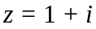, simplify

(a) 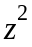 (1 mark)

(b) 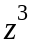 (1 mark)

(c) 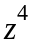 (1 mark)

(d) Plot ,, and on the Argand diagram below. (2 marks)

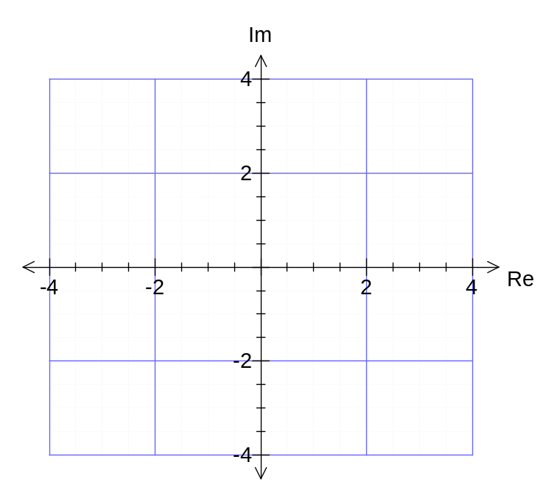

(e) Multiplying z by 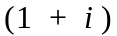 has the effect of rotating z about the origin.
Describe this rotation by stating the angle of rotation and direction of rotation. (1 mark)

(f) Hence, describe the transformation effect when a complex number 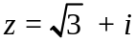 is multiplied by itself each time. (2 marks)

Question 8 (4 marks)

Prove: 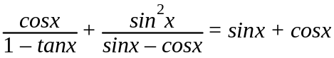

Question 9 (7 marks)

(a) The position vectors of points B and C are 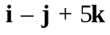 and 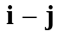 respectively relative to an origin O. Point N lies on BC such that BN:NC = 2:3. Find the position vector of N.
(2 marks)

(b) Find the vector equation of the plane in the form r • n = c passing through (3, -1, 0) and containing the line with 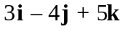 as its normal.
(2 marks)

(b) The plane π has equation r • 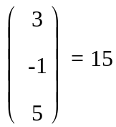 . Show that the line 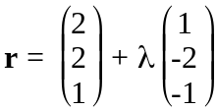 is parallel to the plane π but does not lie in π. (3 marks)

Question 10 (5 marks)

(a) State the inequality that describes the set of points in the complex plane, illustrated
by the shading below. (2 marks)

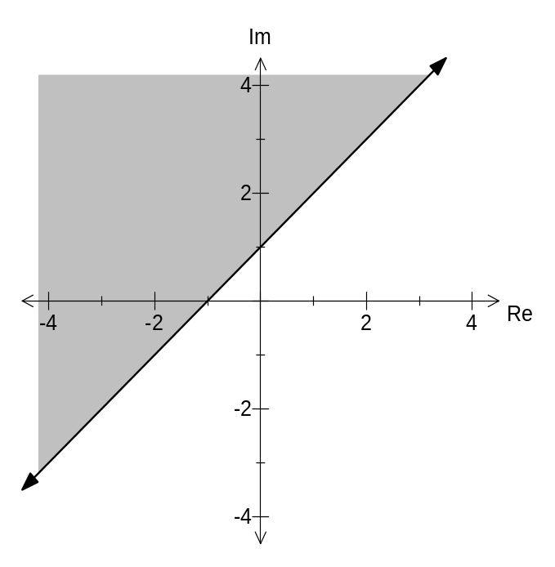

(b) Sketch on the complex plane below, the region defined by:

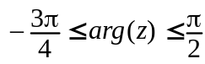 and 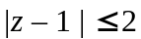 (3 marks)
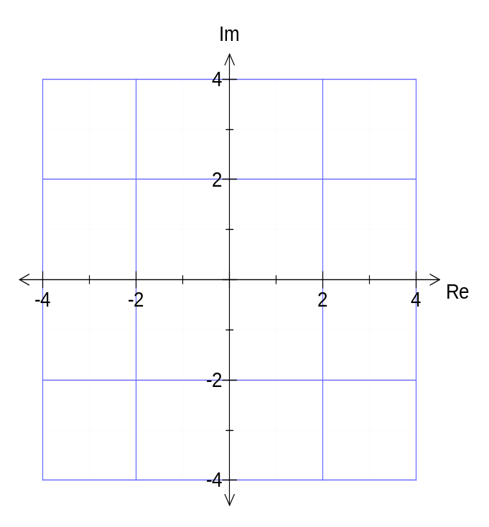

Question 11 (6 marks)

(a) Find the equation of the line L passing through the points A and B with position
vectors 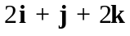 and 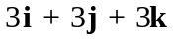 respectively. (2 marks)

(b) Find the point of intersection, D, of line L from part (a) and the plane P such that
the vector equation of P is r • 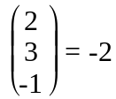. (2 marks)

(c) Find the angle (to the nearest degree) between the line L and the plane at D. (2 marks)

Question 12 (4 marks)

The gradient of a curve at any point is given by 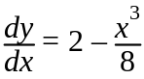 . The curve intersects the x-axis at the point P. Given that the gradient of the curve at P is 1, find the equation of the curve.

Question 13 (6 marks)

(a) Show that 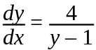 for 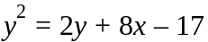. (2 marks)

(b) Show that the tangents to the curve at the points where 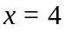 are perpendicular. (4 marks)

Question 14 (5 marks)
The natural logarithm can be expressed as 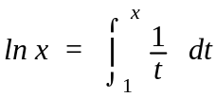

(a) Explain graphically why 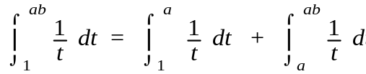 , where 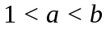 and a and b are constants. (2 marks)

(b) Use the integral definition of the natural logarithm, and where required, the substitution 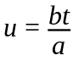, to deduce 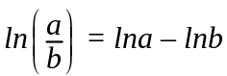 . (3 marks)

Question 15 (6 marks)

O, A and B are non-collinear points on a plane. S is an arbitrary point on the perpendicular
bisector of 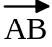 and C is the point of intersection of this bisector and .
Let 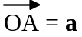, 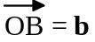, 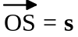, 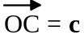 .
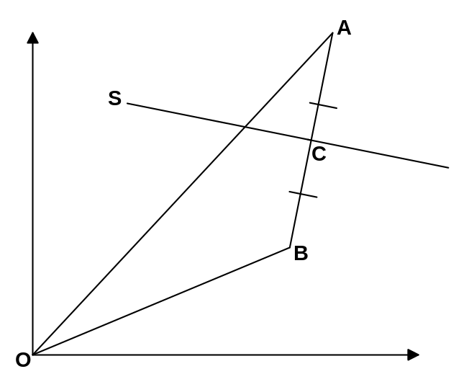

(a) Write  in terms of a and b (1 mark)

(b) Write 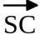 in terms of s and c (1 mark)

(c) Use the fact that SC and BA are perpendicular to prove that
s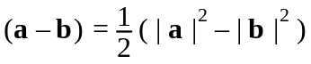 (4 marks)

Question 16 (8 marks)

At 1100 hours at an air show, two planes P and Q are at points whose position vectors are (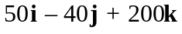) km and (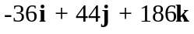) km respectively relative to an origin O.
P and Q are moving with constant velocities (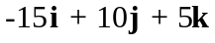) km/min and (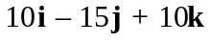) km/min respectively.

(a) Find the coordinates of the point at which their trails of smoke meet. (3 marks)

(b) Determine the shortest distance of plane P from the smoke trail of plane Q at 1102 hours. (5 marks)

Question 17 (6 marks)

The chambers of a nautilus shell are arranged in an approximately logarithmic spiral as shown below.

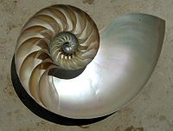 | 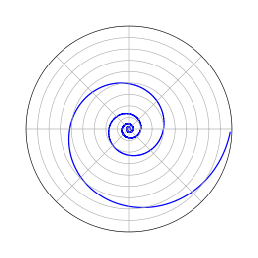
Nautilus Shell | Logarithmic Sprial

In polar form 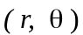 the logarithmic spiral can be written as 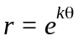 .

The length of this spiral in polar form is 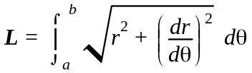

(a) Using show that

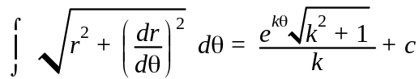 (4 marks)

(b) Given a logarithmic spiral has polar equation 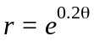, find the length of the spiral correct to 2 decimal places for 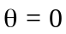 to 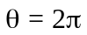. (2 marks)

End of questions
Additional working space
Question number:

Additional working space
Question number:

